# Diabetes Classification Results using RandomForest

## Classification Report:

precision recall f1-score support  
  
 0 0.81 0.78 0.80 153  
 1 0.78 0.81 0.80 147  
  
 accuracy 0.80 300  
 macro avg 0.80 0.80 0.80 300  
weighted avg 0.80 0.80 0.80 300

## ROC AUC Score:

ROC AUC Score (RandomForest): 0.8787070383709039

## ROC Curve:

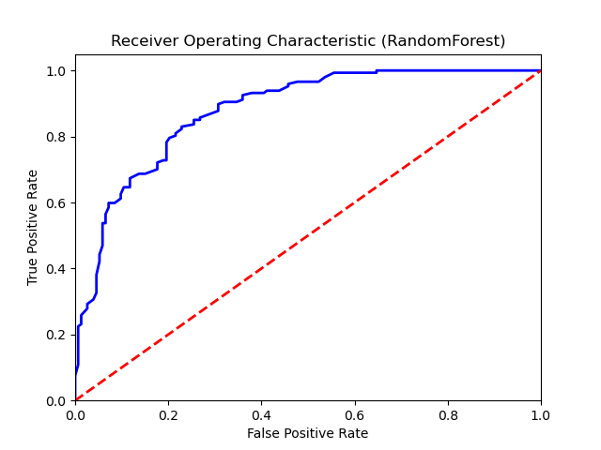

## Confusion Matrix:

True Negatives: 120

False Positives: 33

False Negatives: 28

True Positives: 119

## Confusion Matrix Plot:

